

ip addressing

Introduction to Networking and Security



November 3, 2019

Jamie lu

W0441213

Table of Contents

Introduction: 2

Question 3 3

Question 4 4

Question 5 5

Question 7 8

SCREENSHOT 1 OF ACTIVITY 7.2.4.9 8

SCREENSHOT 2 OF ACTIVITY 7.2.4.9 9

SCREENSHOT 3 OF ACTIVITY 7.2.4.9 10

SCREENSHOT 4 OF ACTIVITY 7.2.4.9 11

SCREENSHOT 5 OF ACTIVITY 7.2.4.9 12

Question 8 13

SCREENSHOT 1 OF ACTIVITY 7.3.2.9 14

SCREENSHOT 2 OF ACTIVITY 7.3.2.9 15

Question 9 16

SCREENSHOT 1 OF ACTIVITY 7.4.1.2 17

SCREENSHOT 2 OF ACTIVITY 7.4.1.2 18

Question 10 19

SCREENSHOT 1 OF MULTIPLE LOCATIONS 3 20

SCREENSHOT 2 OF MULTIPLE LOCATIONS 3 21

SCREENSHOT 3 OF MULTIPLE LOCATIONS 3 22

SCREENSHOT 4 OF MULTIPLE LOCATIONS 3 23

References 24

Appendix 25

Appendix A – Cisco Commands Tool Kit 25

# Introduction:

This assignment contains activities that used learnings from Cisco’s CCNA R&S: Introduction to Networking: Chapters 7[1], as well as, useful information from the Cisco IOS Configuration Fundamentals Command Reference[2]. This assignment also contains the continued information learned and skills acquired with regards to the topics that were covered in this chapter and in Chapter 6, namely, the IP Protocol, IPv4, IPv6, routers and configuring them, enterprise level networking, communications closets and server rooms, and rack mounted equipment. This assignment also contains the continuation of the case study that was mentioned in the previous assignments. It tackles on the knowledge and skills that are required in order to successfully attach devices to a network.

# Question 3

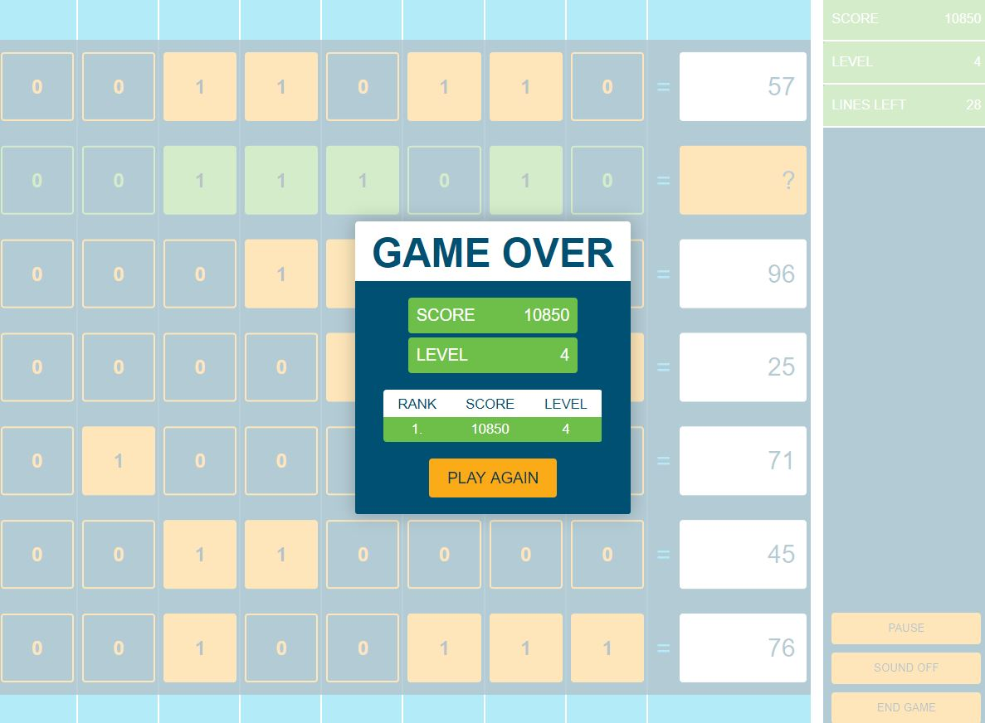

# Question 4

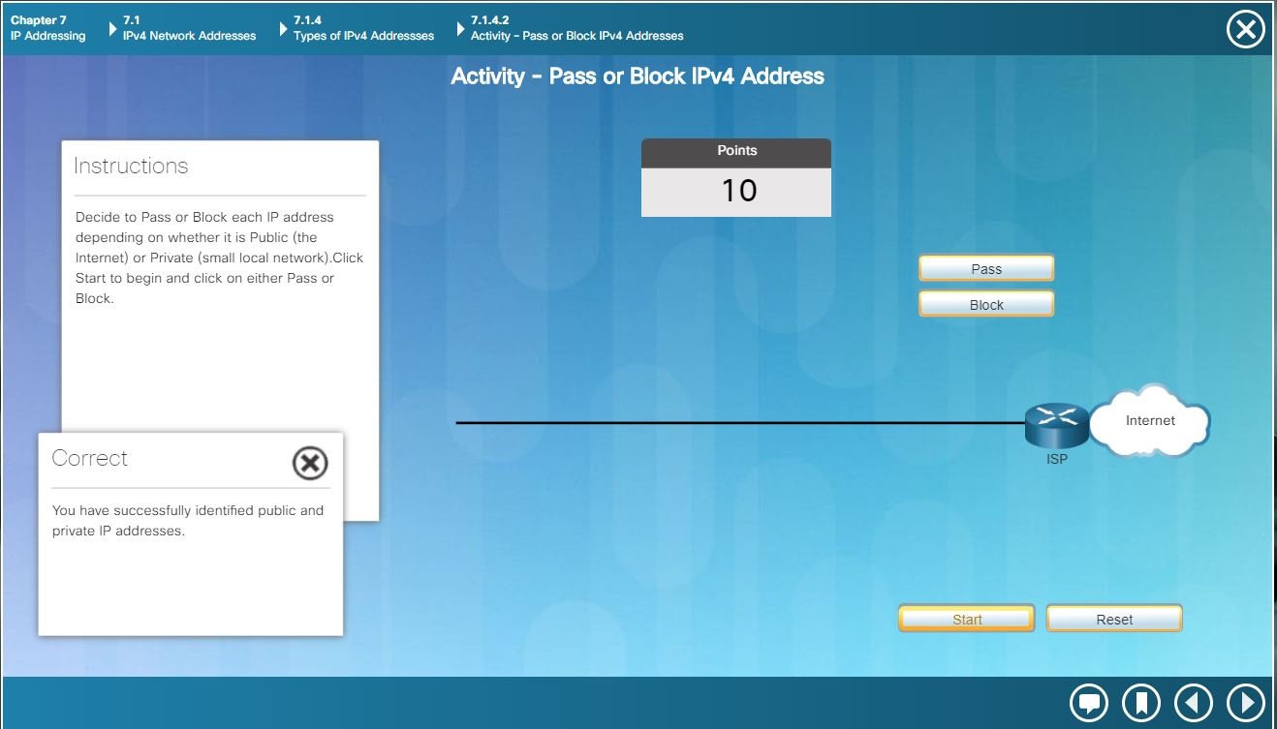

# Question 5

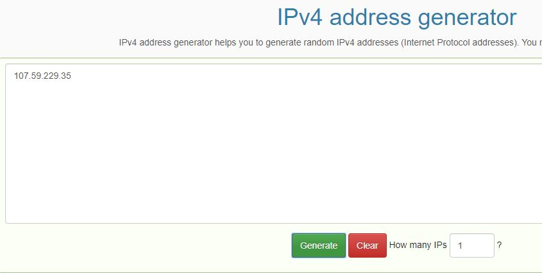

1. Record the random address assigned

**107.59.229.35**

1. Convert the address to 4 binary numbers

* 01101011 00111011 11100101 00100011

|  |  |  |  |  |  |  |  |  |
| --- | --- | --- | --- | --- | --- | --- | --- | --- |
| Conversion | 107  107-64=43  43-32=11  11-8=3  3-2=1  1-1=0 | | | | | | | |
| Bits | 128 | 64 | 32 | 16 | 8 | 4 | 2 | 1 |
| Binary | 0 | 1 | 1 | 0 | 1 | 0 | 1 | 1 |

|  |  |  |  |  |  |  |  |  |
| --- | --- | --- | --- | --- | --- | --- | --- | --- |
| Conversion | 59  59-32=27  27-16=11  11-8=3  3-2=1  1-1=0 | | | | | | | |
| Bits | 128 | 64 | 32 | 16 | 8 | 4 | 2 | 1 |
| Binary | 0 | 0 | 1 | 1 | 1 | 0 | 1 | 1 |

|  |  |  |  |  |  |  |  |  |
| --- | --- | --- | --- | --- | --- | --- | --- | --- |
| Conversion | 229  229-128=101  101-64=37  37-32=5  5-4=1  1-1=0 | | | | | | | |
| Bits | 128 | 64 | 32 | 16 | 8 | 4 | 2 | 1 |
| Binary | 1 | 1 | 1 | 0 | 0 | 1 | 0 | 1 |

|  |  |  |  |  |  |  |  |  |
| --- | --- | --- | --- | --- | --- | --- | --- | --- |
| Conversion | 35  35-32=3  3-2=1  1-1=0 | | | | | | | |
| Bits | 128 | 64 | 32 | 16 | 8 | 4 | 2 | 1 |
| Binary | 0 | 0 | 1 | 0 | 0 | 0 | 1 | 1 |

1. Convert the address to 4 hexadecimal numbers
   * 6B.3B.E5.23
   * 01101011 = 6B
   * 00111011 = 3B
   * 11100101 = E5
   * 00100011 = 23

0110 1011

|  |  |  |  |  |  |  |  |  |  |
| --- | --- | --- | --- | --- | --- | --- | --- | --- | --- |
| Hexadecimal | 8 | 4 | 2 | 1 |  | 8 | 4 | 2 | 1 |
| Binary | 0 | 1 | 1 | 0 |  | 1 | 0 | 1 | 1 |
| Count | 0 | 4 | 2 | 0 |  | 8 | 0 | 2 | 1 |
| Conversion | 4+2 = 6 | | | |  | 8+2+1=11 B | | | |
|  | 6 + A = **6B** | | | | | | | | |

0011 1011

|  |  |  |  |  |  |  |  |  |  |
| --- | --- | --- | --- | --- | --- | --- | --- | --- | --- |
| Hexadecimal | 8 | 4 | 2 | 1 |  | 8 | 4 | 2 | 1 |
| Binary | 0 | 0 | 1 | 1 |  | 1 | 0 | 1 | 1 |
| Count | 0 | 0 | 2 | 1 |  | 8 | 0 | 2 | 1 |
| Conversion | 2+1=3 | | | |  | 8+2+1=11=B | | | |
|  | 3 + B = **3B** | | | | | | | | |

1110 0101

|  |  |  |  |  |  |  |  |  |  |
| --- | --- | --- | --- | --- | --- | --- | --- | --- | --- |
| Hexadecimal | 8 | 4 | 2 | 1 |  | 8 | 4 | 2 | 1 |
| Binary | 1 | 1 | 1 | 0 |  | 0 | 1 | 0 | 1 |
| Count | 8 | 4 | 2 | 0 |  | 0 | 4 | 0 | 1 |
| Conversion | 8+4+2=14 = E | | | |  | 4+1=5 | | | |
|  | E + 5 = **E5** | | | | | | | | |

0010 0011

|  |  |  |  |  |  |  |  |  |  |
| --- | --- | --- | --- | --- | --- | --- | --- | --- | --- |
| Hexadecimal | 8 | 4 | 2 | 1 |  | 8 | 4 | 2 | 1 |
| Binary | 0 | 0 | 1 | 0 |  | 0 | 0 | 1 | 1 |
| Count | 0 | 0 | 2 | 0 |  | 0 | 0 | 2 | 1 |
| Conversion | 2=2 | | | |  | 2+1=3 | | | |
|  | 2 + 3 = **23** | | | | | | | | |

1. What is the default subnet mask for your address?
   * 255.0.0.0 or 11111111 00000000 00000000 00000000 because it is part of the Class A IP class
2. What network address contains your address?
   * The network address is 107.0.0.0 or 01101011 00000000 00000000 00000000
   * The broadcast address is 107.255.255.255

|  |  |  |  |  |  |  |  |  |  |  |  |  |  |  |  |  |  |  |  |  |  |  |  |  |  |  |  |  |  |  |  |  |
| --- | --- | --- | --- | --- | --- | --- | --- | --- | --- | --- | --- | --- | --- | --- | --- | --- | --- | --- | --- | --- | --- | --- | --- | --- | --- | --- | --- | --- | --- | --- | --- | --- |
| IP IN BINARY | 0 | 1 | 1 | 0 | 1 | 0 | 1 | 1 | 0 | 0 | 1 | 1 | 1 | 0 | 1 | 1 | 1 | 1 | 1 | 0 | 0 | 1 | 0 | 1 | 0 | 0 | 1 | 0 | 0 | 0 | 1 | 1 |
| DEFAULT SUBNET MASK IN BINARY | 1 | 1 | 1 | 1 | 1 | 1 | 1 | 1 | 0 | 0 | 0 | 0 | 0 | 0 | 0 | 0 | 0 | 0 | 0 | 0 | 0 | 0 | 0 | 0 | 0 | 0 | 0 | 0 | 0 | 0 | 0 | 0 |
| AFTER ANDING | 0 | 1 | 1 | 0 | 1 | 0 | 1 | 1 | 0 | 0 | 0 | 0 | 0 | 0 | 0 | 0 | 0 | 0 | 0 | 0 | 0 | 0 | 0 | 0 | 0 | 0 | 0 | 0 | 0 | 0 | 0 | 0 |

107 0 0 0

# 

# Question 7

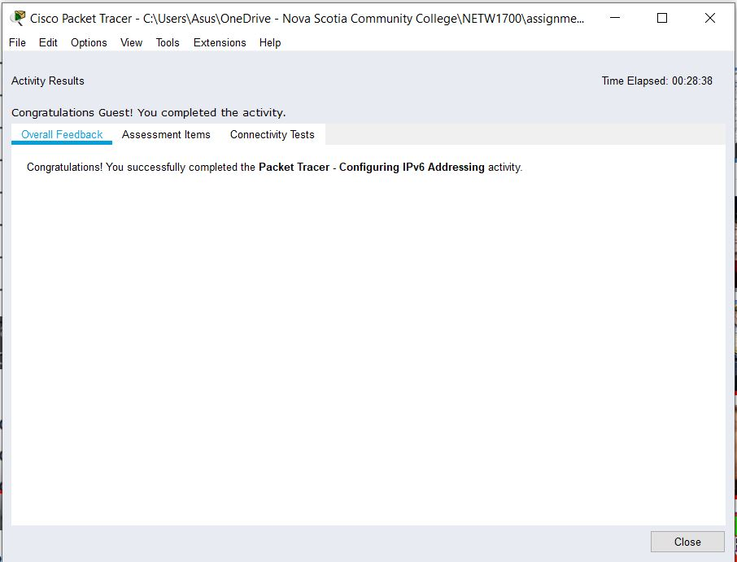

SCREENSHOT 1 OF ACTIVITY 7.2.4.9

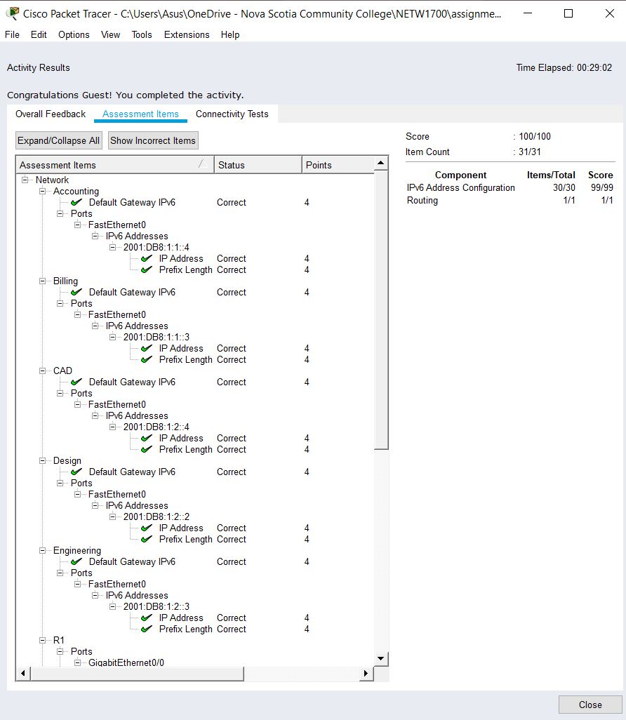

SCREENSHOT 2 OF ACTIVITY 7.2.4.9

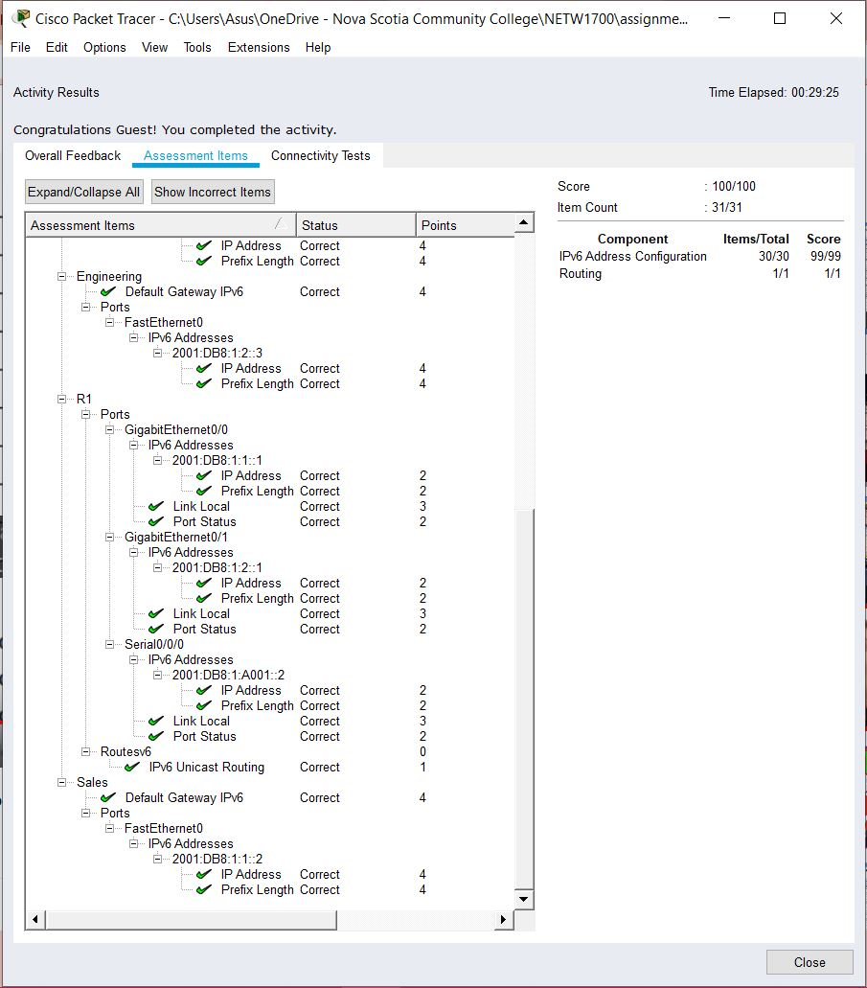

SCREENSHOT 3 OF ACTIVITY 7.2.4.9

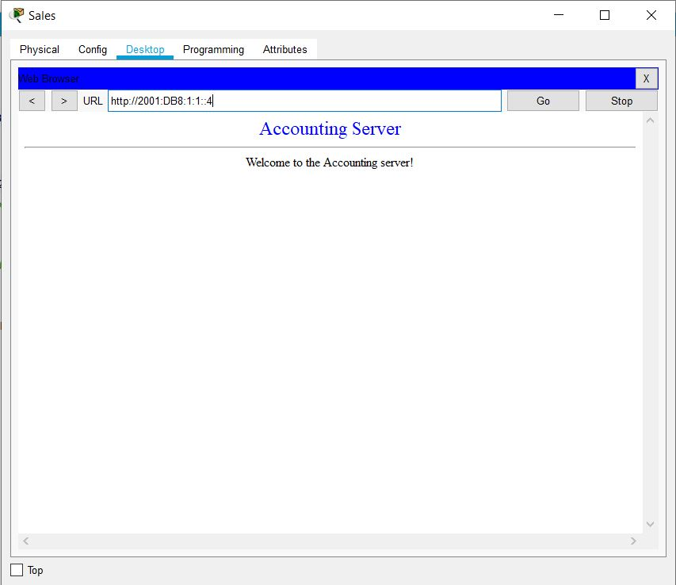

SCREENSHOT 4 OF ACTIVITY 7.2.4.9

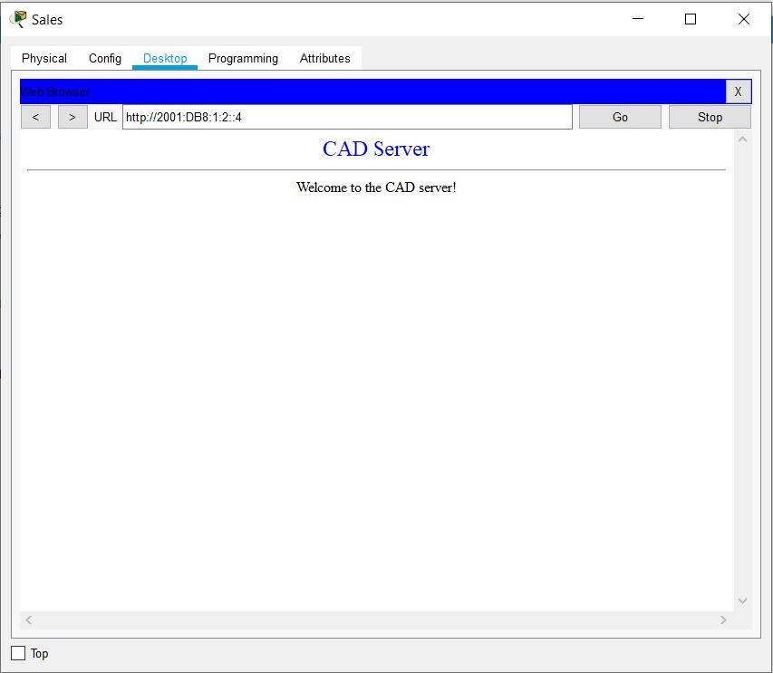

SCREENSHOT 5 OF ACTIVITY 7.2.4.9

# Question 8

**TROUBLESHOOT 1ST ISSUE:**

Client Identifier: PC1

Issue: Unable to access the dualstackserver.pka web page.

Cause: IPv4 DNS address for PC1 is incorrect.

Solution: Change the DNS Server PC1 to what is specified in the table which is 64.100.1.254.

**TROUBLESHOOT 2nd ISSUE:**

Client Identifier: PC2

Issue: Unable to access the FTP service of 2001:DB8:CAFE:1::10

Cause: DualStackServer.pka’s IPv6 gateway address is incorrect.

Solution: Change the Dual Stack Server’s IPv6 gateway to what is specified in the table which is FE80::A.

**TROUBLESHOOT 3RD ISSUE:**

Client Identifier: PC3

Issue: Unable to communicate with PC2.

Cause: PC2’s IPv4 gateway address is incorrect.

Solution: Set the default gateway for PC2 to 192.168.0.1.

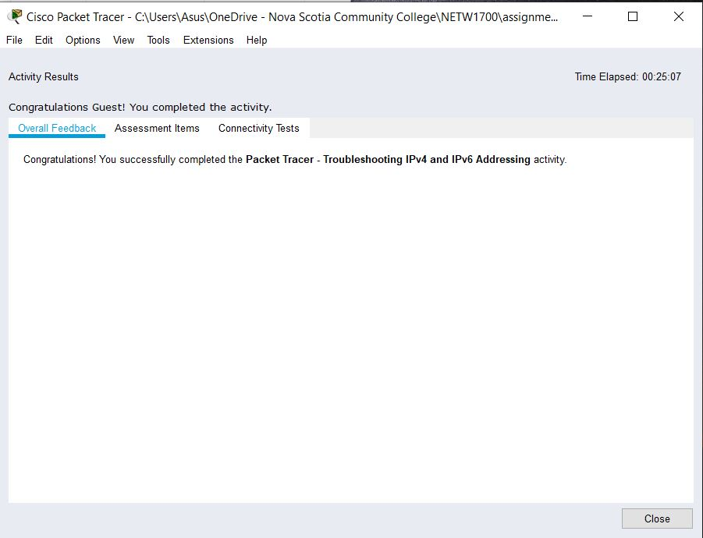

SCREENSHOT 1 OF ACTIVITY 7.3.2.9

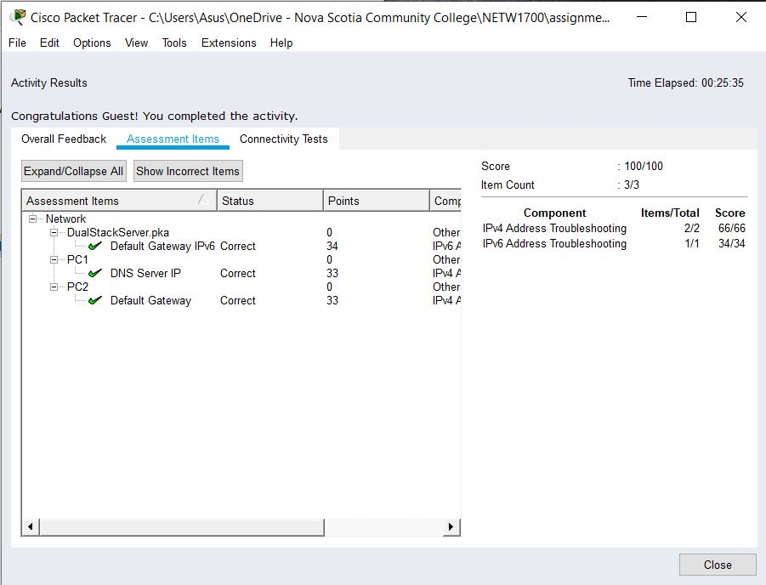

### SCREENSHOT 2 OF ACTIVITY 7.3.2.9

# Question 9

Missing Default Gateways:

Manager A:

172.16.10.1

FE80::1

Accounting.pka:

172.16.10.1

FE80::1

Manager B:

172.16.10.65

FE80::1

Website.pka:

172.16.10.65

FE80::1

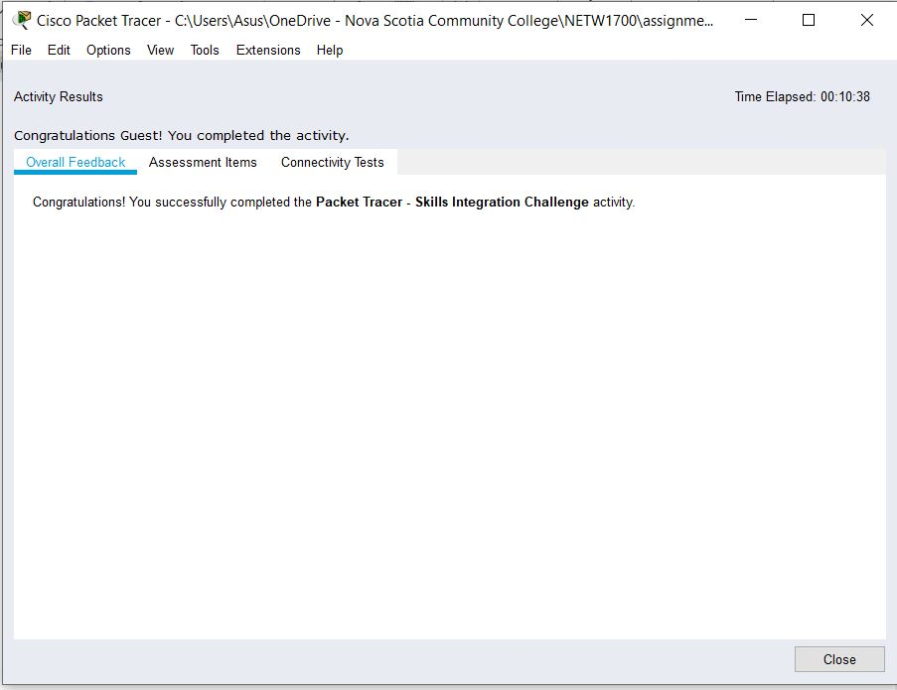

SCREENSHOT 1 OF ACTIVITY 7.4.1.2

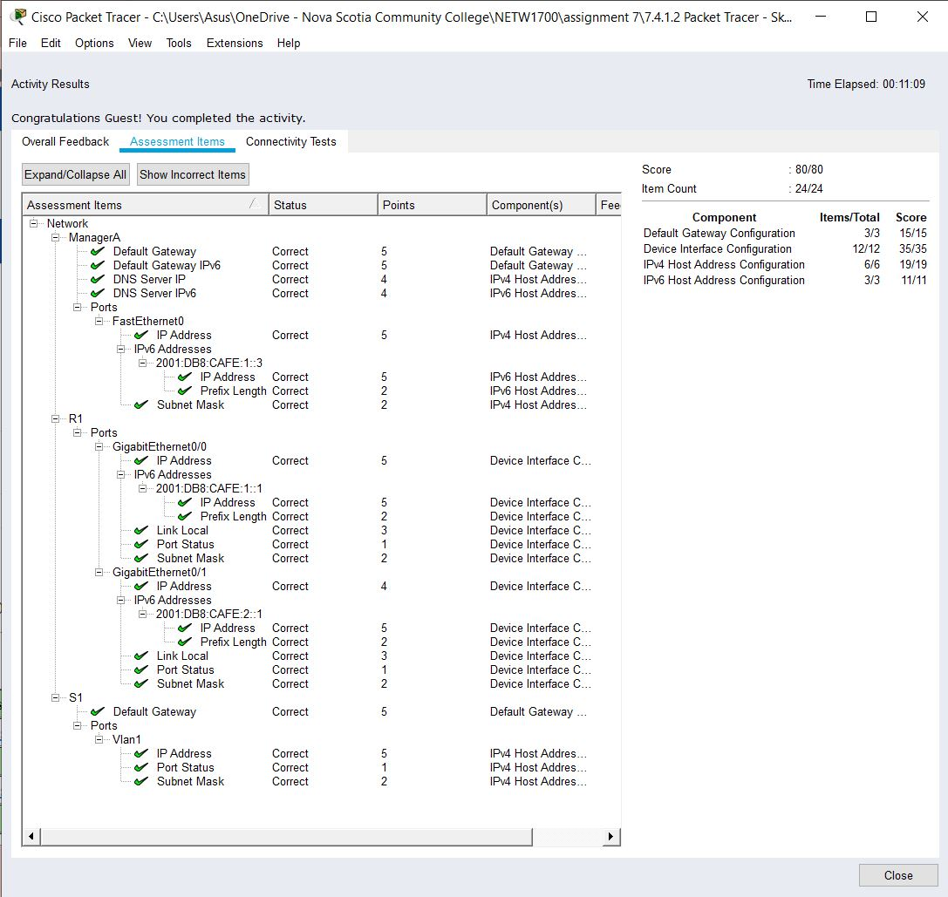

### SCREENSHOT 2 OF ACTIVITY 7.4.1.2

# Question 10

PC-PT 1A:

IP Address: 192.168.3.1

Subnet Mask: 255.255.255.224

Default Gateway: 192.168.3.30

PC-PT 1B:

IP Address: 192.168.3.2

Subnet Mask: 255.255.255.224

Default Gateway: 192.168.3.30

Eagle Server

IP Address: 192.168.3.77

Subnet Mask: 255.255.255.240

Default Gateway: 192.168.3.78

Switch 1

IP Address: 192.168.3.29

Subnet Mask: 255.255.255.224

R1-ISP

Fa0/0

IP Address: 192.168.3.78

Subnet Mask: 255.255.255.240

S0/0/0

IP Address: 192.168.3.98

Subnet Mask: 255.255.255.252

R2-Central

Fa0/0

IP Address: 192.168.3.30

Subnet Mask: 255.255.255.224

S0/0/0

IP Address: 192.168.3.97

Subnet Mask: 255.255.255.252

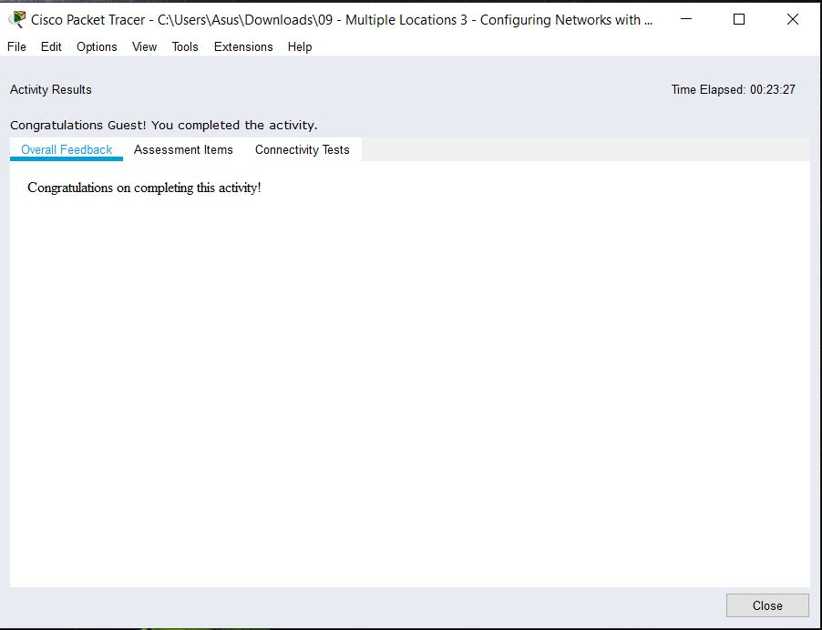

SCREENSHOT 1 OF MULTIPLE LOCATIONS 3

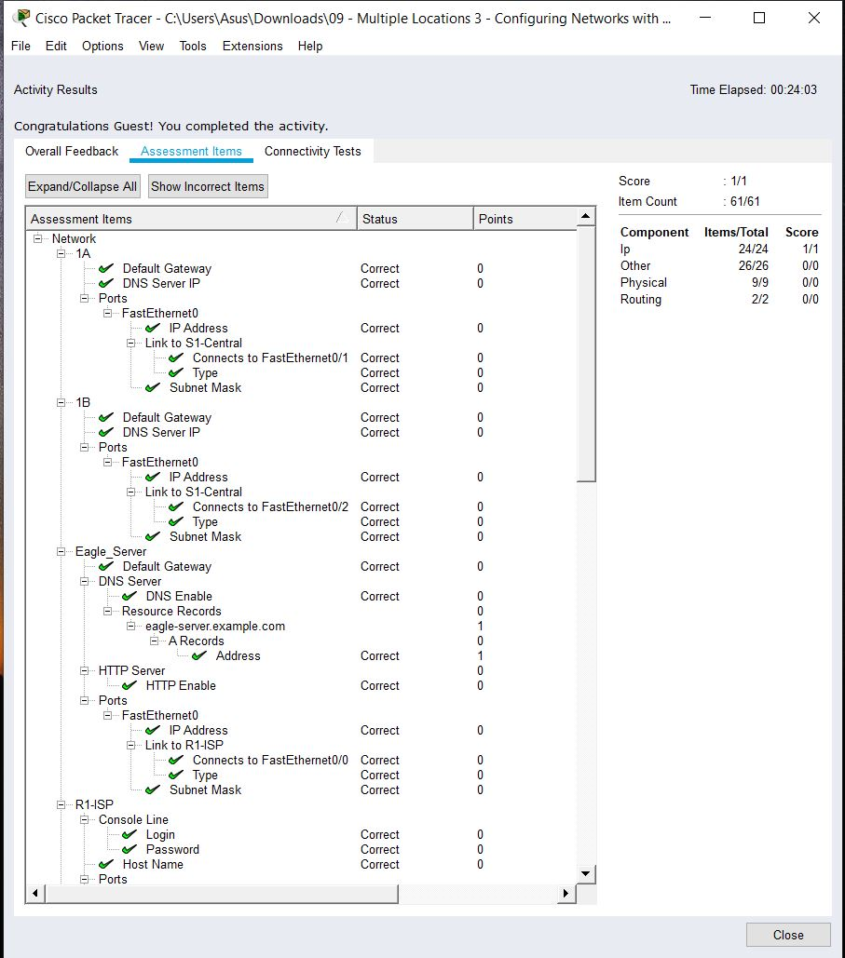

SCREENSHOT 2 OF MULTIPLE LOCATIONS 3

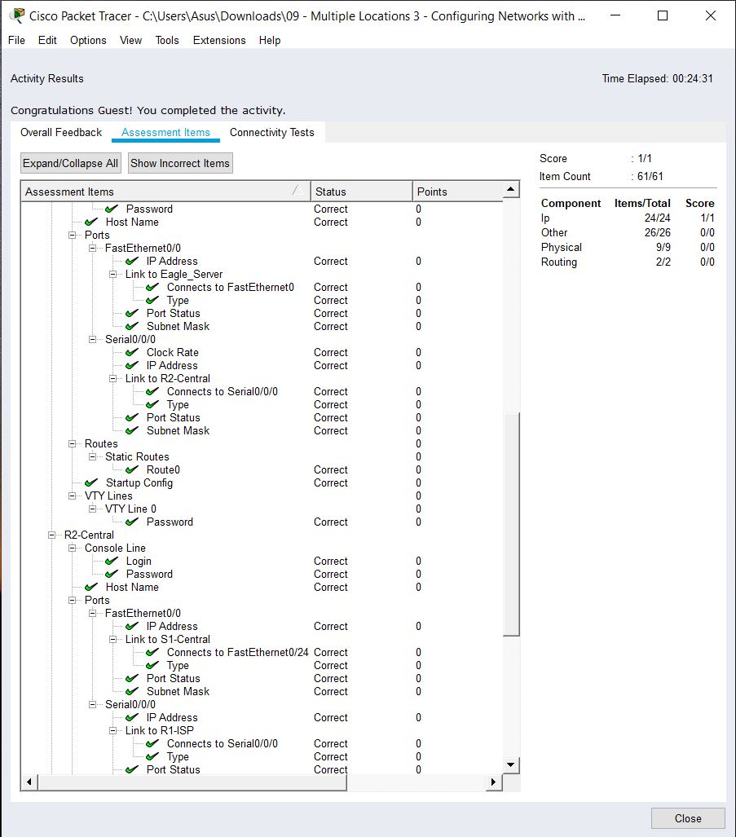

SCREENSHOT 3 OF MULTIPLE LOCATIONS 3

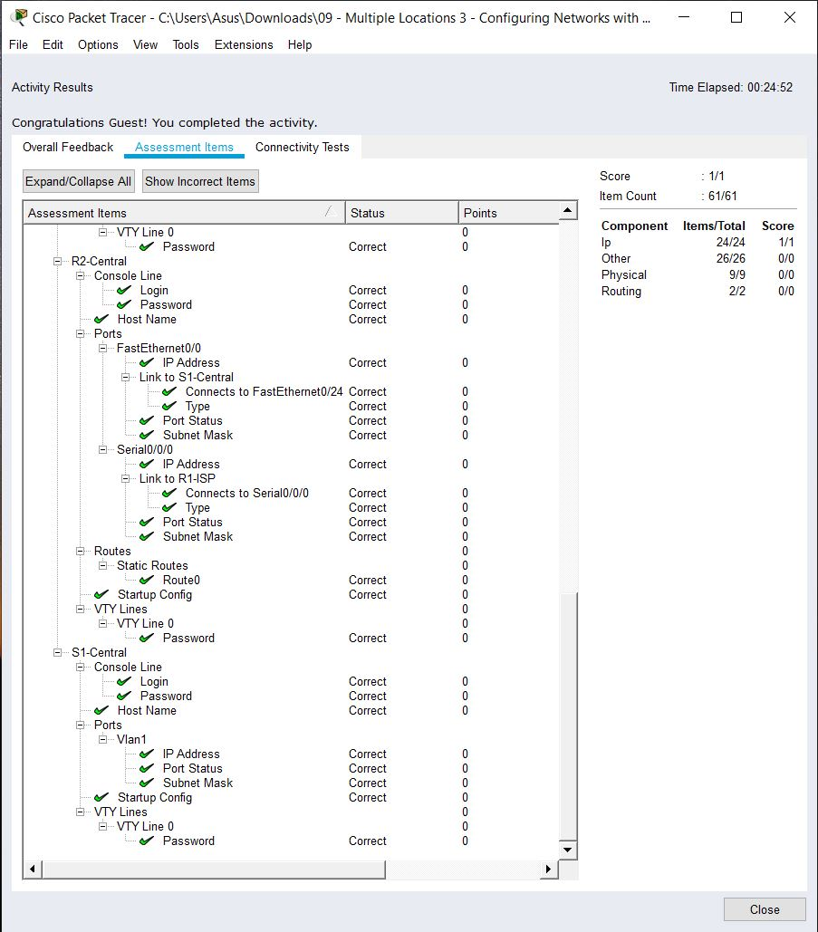

SCREENSHOT 4 OF MULTIPLE LOCATIONS 3

# References

Cisco. (n.d.). *Chapter: Configuring Static Routing*. Retrieved October 30, 2019, from Cisco: https://www.cisco.com/c/en/us/td/docs/switches/datacenter/nexus3000/sw/unicast/503_u1_2/nexus3000_unicast_config_gd_503_u1_2/l3_route.html

Cisco Networking Academy. (n.d.). *Introduction to Networks, Chapter 2: Configure a Network Operating System*. Retrieved October 10, 2019, from Cisco Networking Academy: https://static-course-assets.s3.amazonaws.com/ITN6/en/index.html#2

Cisco Systems, Inc. (2010, April). *Cisco IOS Configuration Fundamentals*. Retrieved from Cisco: https://www.cisco.com/c/en/us/td/docs/ios/fundamentals/command/reference/cf_book.pdf

# 

# Appendix

## Appendix A – Cisco Commands Tool Kit[3]

**?** – this command will show the list of all the commands available for the specific mode you are currently in.

**(characters) ?** – this command is known as context-sensitive help. it will show the available commands in the current mode with the specific first characters you have entered. (example: **te?** in the user exec mode will show **te**lnet and **te**rminal, both starting with **te**.)

**banner motd “ ”** – this command will configure the message-of-the-day banner that will display when a user logs in to the switch.

**clock rate (rate)** – this command is used in DCE in serial link. This command configures the clock speed for the ink

**clock set (time and date)** – this command will allow you to set the time and date. (example: **clock set 15:00:00 july 11 2019)**

**copy startup-config flash –** this command will save the startup configuration to the flash memory. The flash memory is good to use as a back up.

**copy running-config startup-config** – this command will save the running configuration to the startup configuration.

**config terminal** – this command will open the global configuration mode.

**description Link to (server name)** – to describe the interface of the specified server.

**enable** – this command will open the privileged exec mode and will give additional commands.

**enable password** – this command followed by a password will set that same password for the privileged exec mode.

**enable secret** – this command followed by a password will set an ***encrypted*** password for the privileged exec mode.

**exit** – this command will exit the current mode.

**Flash –** this command will boot the router from Flash memory

**ip default-gateway –** this command will set the default gateway

**hostname** – this command followed by the name you want the hostname to be will change the hostname to what you want it to be.

**interface** – followed by the interface you want to configure will open that specific interface’s configuration mode.

EXAMPLES:

**interface fa0/0** - enter interface configuration mode for the FastEthernet interface

**interface s0/0/0** – enter interface configuration mode for the serial interface

**interface vlan <1-4094>**– you can use this command to configure an svi on a switch.

**ip address ­**– this command followed by the ip address and subnet mask you want will set the ip address and subnet mask to the entered values.

**ip route {ip-prefix | ip-addr ip-mask} {[next-hop | nh-prefix] | [interface next-hop | nh-prefix]} [tag tag-value [pref]][4] –** this command configures a static route and the interface for the static route.

EXAMPLE:

switch(config)# ip route 192.0.2.0/8 ethernet 1/2 192.0.2.4

switch(config)# ip route 192.0.2.0/8 192.0.2.10

**ipv6 unicast-routing –** in global configuration mode, this command will enable the router to forward IPv6 packets

**ipv6 address <ipv6 address> -** this command will manually assign a specific ipv6 address to an interface. Used in interface configuration mode. Insert no before ipv6 address to remove the address from an interface.

**ipv6 address <link local address> link-local-** this command manually assigns a specific link-local address to an interface and enables IPv6 processing on an interface. Used in interface configuration mode. Insert no before ipv6 address to remove the address from an interface.

**line** – this command will configure a terminal line.

**line console 0** – this command will open the line console configuration mode.

**line vty 0 15** – this command will open the virtual terminal configuration mode.

**login** – this command will enable password checking

**no shutdown** – this command enables an interface.

**password** – this command will set a password.

**ping** – this command will send a request to the destination and wait for the response. this is good for checking network connectivity.

**service password-encryption** – this command in the global config mode will encrypt all unencrypted passwords in the configuration file.

**show interface** – this command will display the status of the interfaces.

**show ip interface** – this command will display the configuration and status of the ip protocol.

**show ip interface brief** – this command gives a summary of the status and IP addresses of the interfaces

**show ip static-route[5] –** this command will display information about the static routes

**Show flash –** this command will show the files on the flash memory.

**show running-config –** this command will show the running configuration

**show startup-config** – this command will show all the startup configuration file.

**show clock** – this command will show the time and date.

***show?*** – this command would show all the show commands in the specific mode you are currently in.

1. (Cisco Networking Academy, n.d.)
2. (Cisco Systems, Inc., 2010)
3. References and sources from (Cisco Systems, Inc., 2010)
4. Referenced from: (Cisco, n.d.)
5. Referenced from: (Cisco, n.d.)